Core Standards and Specifications Vocabulary

Public consultation initiation

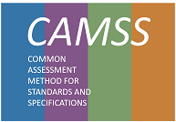

**Change Control**

|  |  |
| --- | --- |
| **Modification** | **Details** |
| **Version 1.0.0** | |
| **Final version** |  |

Disclaimer

The information and views set out in this publication are those of the author(s) and do not necessarily reflect the official opinion of the Commission. The Commission does not guarantee the accuracy of the data included in this document. Neither the Commission nor any person acting on the Commission’s behalf may be held responsible for the use which may be made of the information contained therein.

© European Union, 2017

TABLE OF CONTENTS

1. Introduction 5

1.1. Context 5

1.2. The Problem Statement 5

1.3. Scope 6

1.4. Proposed solution 6

1.5. Structure of this document 6

2. Related Solutions 6

2.1. CAMSS Ontology 7

2.2. Core Assessment Vocabulary (CAV) 7

2.3. EIRA Library of Interoperability Specifications (ELIS) 7

2.4. DCAT-AP and ADMS-AP 7

3. Core Standards and Specifications Vocabulary 9

3.1. Data Model for the CSSV 10

3.1.1. Interpretation of the model 10

3.2. Class: Specification 11

3.2.1. Property: dct:identifier 12

3.2.2. Property: dct:type 12

3.2.3. Property: dct:description 12

3.2.4. Property: cssv:ShortName 12

3.2.5. Property: cssv:LongName 12

3.2.6. Property: cssv:Purpose 12

3.2.7. Property: cssv:PurposeID 13

3.2.8. Property: cssv:includedIn 13

3.2.9. Property: cssv:combinedIn 13

3.3. Class: cssv:Standard 13

3.4. Class: cssv:ApplicationProfile 13

3.4.1. Property: cssv:Configures 13

3.5. Class: cssv:Family 14

3.5.1. Property: cssv:combines 14

4. Conformance statement 14

5. Accessibility and Multilingual Aspects 14

6. Acronyms 15

7. References 15

Table of Figures

Figure 1: DCAT-AP classes and properties 8

Figure 2: ADMS-AP model 9

Figure 3: CSSV Data model 10

# Introduction

## Context

The ISA2 programme of the European Commission supports the development of solutions that enable the cross-border delivery of interoperable public services in Europe. In order to ensure the interoperability of those services, the EIA action works as an integrator between the Member States and other departments of the European Commission for the development of a joint interoperability architecture for public services. The main output of this action is the European Interoperability Reference Architecture (EIRA©[1]).

As an element of EIRA©, the EIRA Library of Interoperability Specifications (ELIS[2]) was created. The ELIS contains the specifications describing the interoperability requirements of the architecture building blocks (ABBs) that conform to EIRA©.

At the core of the ELIS there is also another asset developed in the context of the CAMSS[3] action that shall be referenced which has been further developed and is the reason for this public consultation: the **Core Standards and Specifications Vocabulary (CSSV).**

## The Problem Statement

|  |  |
| --- | --- |
| **The problem statement** | At the present stage there is not a clear definition of what a specification, a standard, a family of specifications and an application profiles are. Similarly, it is not clearly expressed how the standards and specifications are related, and what are their purposes and constraints. Moreover discovering and cataloguing interoperability assets – such as EIRA building blocks— with standards and specifications that support their development is currently a hard and time-consuming task. This situation |
| **affects** | all European public administrations, citizens, among others, that need to use specifications or to make reference to them, for the description of specifications in order to facilitate their identification, use, cataloguing and exchange between systems (e.g. ELIS); |
| **the impact of which is** | that the building of electronic catalogues is hampered by problems during the discovery and cataloguing of specifications. This impacts the research of specifications in the catalogue and the users researching specifications. Ultimately, the difficulty in identifying and getting information about the specifications hinders its reuse, the possibility of assessing the conformance of the specifications to regulated purposes and frameworks (scenarios) and, therefore, to formally support other needs and developments. |
| **A successful solution would be** | to come up with a common vocabulary that is able to clearly define the main concepts related to standards and specifications. |

## Scope

The objective of this public consultation is to produce a very first release of a “Core Standards and Specifications Vocabulary” (CSSV) which will be used for the development of the new ELIS release and for any need of information exchange related to standards and specifications amongst software solutions. The update of this release of the CSSV will be based on requests for change coming from stakeholders interested in the Vocabulary.

The Core Standards and Specifications (CSSV) specified in this document has been developed taking in inputs from different sources, namely the works developed for the ISA2’s CAMSS Action, interested MS, the Semantic Interoperability Community (SEMIC) action of the ISA2 Programme and IT consultants working for the European Commission.

## Proposed solution

The CSSV defined in this document is based on a preliminary Core Interoperability Standards and Specifications Vocabulary (CISSV) and EIRA CISSV-AP model, which was used for the development of the BETA version of the ELIS in 2018. The CSSV thus replaces that other preliminary model.

## Structure of this document

This document consists of the following sections:

* Section 2 describes the related solutions to the Core Standards and Specifications Vocabulary (CSSV).
* Section 3 explains the CSSV model and identifies the classes and properties defined for the vocabulary.
* Section 4 contains the Conformance Statement for this vocabulary.
* Section 5 describes specific accessibility and multilingualism aspects.
* Section 6 list the different acronyms used through the whole document.
* Section 7 contains related references.

# Related Solutions

This section lists the different related solutions to the CSSV. Note that some of them are still under development.

## CAMSS Ontology

CAMSS stands for Common Assessment Method for Standards and Specifications and it is an action of the ISA2 Programme[4].

The CAMSS Ontology defines the CAMSS terminology and axioms that define the CAMSS concepts and logic rules. The interpretation of the CAMSS concepts cast a clear idea of the method defined in CAMSS to assess standards and specifications.

The CAMSS Ontology is currently under development.

## Core Assessment Vocabulary (CAV)

The Core Assessment Vocabulary represents, expresses and defines what an “Assessment” of “Assets” is and how to perform the assessment based on “Criteria”. It is a domain-agnostic vocabulary, meaning that it can be used to assess any asset. Hence, the CAV is at very core of the CAMSS Ontology. Or, in other words, the CAMSS Ontology reuses and extends the CAV.

The CAV is also under development. The current CAMSS tool, the CAMSS Ontology, the ELIS and other projects under development are being used to test and refine the CAV.

## EIRA Library of Interoperability Specifications (ELIS)

The ELIS is a family of interoperability specifications that define the interoperability aspects of the Architecture Building Blocks (ABBs) contained in EIRA©. Its aim is supporting architects for the modelling of solutions based on EIRA©. The current version of ELIS will have to be slightly revamped to accommodate to the concepts defined in the CSSV and support the requirement of all the stakeholders, e.g. EIRA-based solution developer needs, NATO profiles, other.

The CSSV is based on the CISSV model, which was used for the development of the BETA version of the ELIS in 2018.

## DCAT-AP and ADMS-AP

The DCAT Application profile for data portals in Europe (DCAT-AP[5]) is a specification based on W3C's Data Catalogue vocabulary (DCAT[6]) for describing public sector datasets in Europe. The Asset Description Metadata Schema (ADMS[7]) in turn was developed as an application profile of the DCAT vocabulary for the description of assets. Hence, DCAT-AP can be used to describe any type of asset (treated as a dataset, especially if you consider that metadata are also data).

The figure below shows the DCAT-AP classes and properties:

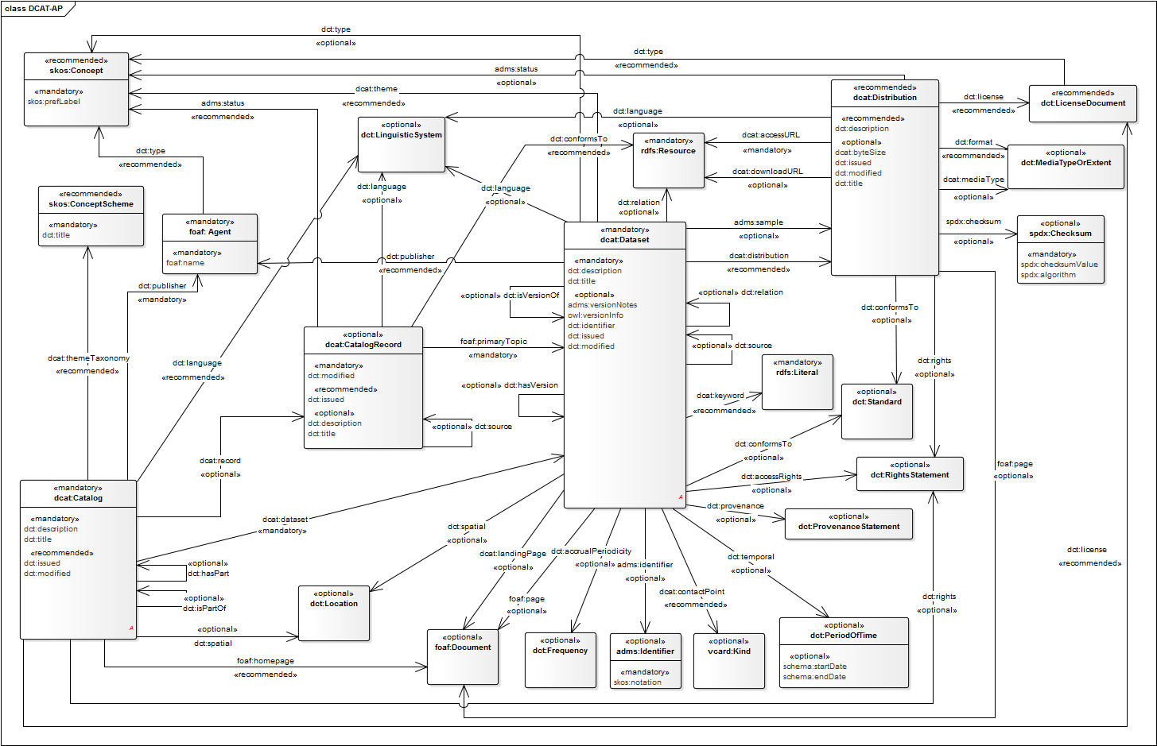

Figure 1: DCAT-AP classes and properties

In the CSSV model, the class Specification can be consider the “root” class and it is an “Asset” as defined in ADMS, which in turn inherits from the *dcat:Dataset class*. The figure below shows how ADMS defines the concept Asset, based on DCAT:

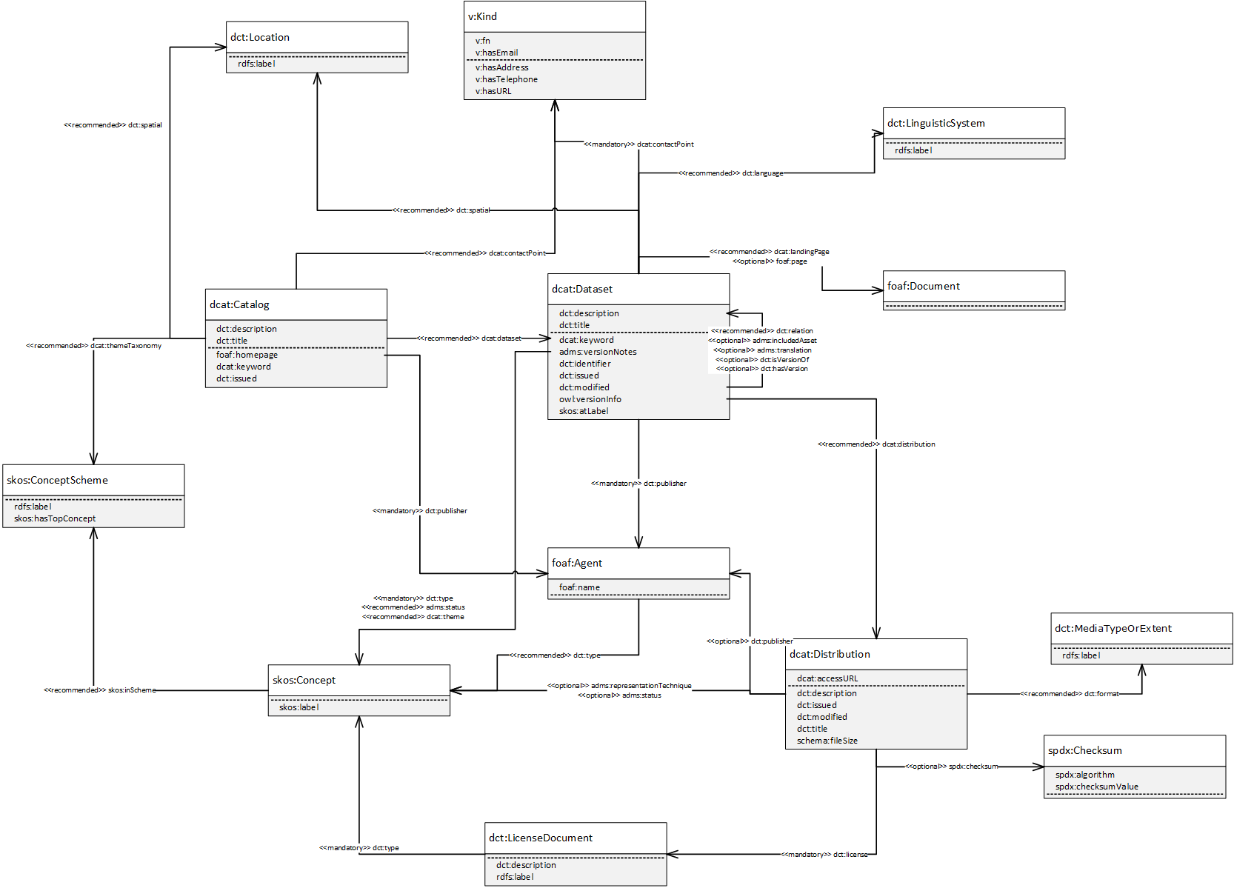

Figure 2: ADMS-AP model

# Core Standards and Specifications Vocabulary

The Core Standards and Specifications Vocabulary is depicted in Figure 3 CSSV Data model. The figure shows the classes and properties that are used or defined in the CSSV.

## Data Model for the CSSV

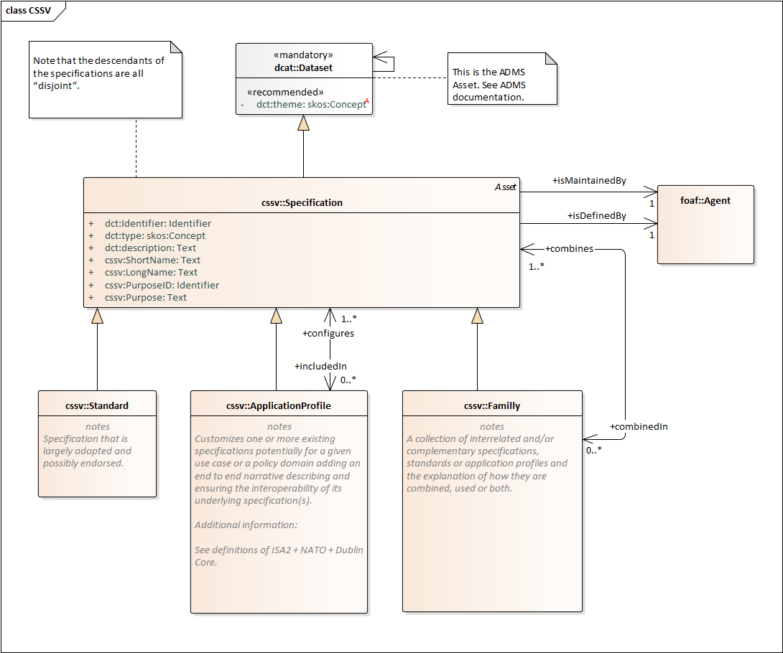

Figure 3: CSSV Data model

### Interpretation of the model

The main class of the CSSV model is the “Specification”. A Specification is an asset, as it inherits from the *dcat:Dataset*, which is the representative of an ADMS Asset.

A Specification, additionally, can be a Standard, an ApplicationProfile and or a Family or a collection of other specifications. The CSSV model defines:

* A **Standard** as agreed, descriptive and normative statements concerning an asset;
* An **ApplicationProfile** as a customisation of one or more existing specifications potentially for a given use case or a policy domain adding an end-to-end narrative describing and ensuring the interoperability of its underlying specification(s). By customisation we understand the “addition of more specificity by identifying mandatory, recommended and optional elements, as well as by defining controlled vocabularies to be employed”.
* A **Family** as a collection of interrelated and/or complementary specifications, standards or application profiles and the explanation of how they are combined, used or both.

A collection of Specifications differs from a Family of Specifications in the fact that the relation amongst themselves is not explicit. In the CSSV model a collection of Specifications is an Asset that is related to other Assets and that is realised as an individual of a Specification. In other words, a Specification that reuses the *dct:relation* property of its base class *dcat:Dataset*.

There are occasions where collections of Specifications are applied to a context or a domain in a specific “configuration”. Thus application profiles may conform sets of “themed” specifications. For this, the CSSV model uses the property “configures/includedIn” and the *dcat:theme* property pointing at a *skos:Concept* (i.e. a code, see the DCAT model above).

It is important to note that the descendants of the specifications are all “disjoint”. Thus, ApplicationProfiles, and Families are Specifications that refer to or put together other Specifications and/or Standards, but cannot themselves be considered Standards.

One Specification, in time, may become a Standard. In these cases the authority (author) that defined the Specification may be different from the one that create and maintains artefacts out of the Standard. Think for example of the artefacts produced, maintained and distributed by the Publications Office of the European Union (OP) in its site EU Vocabularies[8]: all these artefacts are defined by other authorities (e.g. the ISO), whilst the artefacts (e.g. the controlled vocabularies expressed in SKOS, XML, GeneriCode, XML, etc.) are supplied by the OP. For this, the CSSV uses the properties *ccsv:isDefinedBy* and *cssv:isMaintainedBy*. Additionally, the *dcat:Dataset* has the property *dct:type* that can be used to state that the Specification is of type “definition, artefact or other”. The DCAT vocabulary also provides the possibility of expressing who is responsible for the publication of the definition or the artefacts via the property *dct:publisher* (see the ADMS and DCAT models).

The author, maintainer or publisher of a Specification is a *foaf:Agent*, which allows a great flexibility to the CSSV model as *foaf:Agent* is the base class in many ontologies. The CSSV puts forward the reuse of the Core Person Vocabulary and the Organization Ontology for this purpose.

Finally, note that all the descendants of the *ccsv:Specification* are disjoint. This entails that an individual of an application profile or family cannot be a standard, but does not preclude that, in time, the application profile or the family can become standards. If that were the case then individuals of ccsv:Standard would be created to represent the standardisation of those specifications that are application profiles and families.

## Class: Specification

A specification has to be understood as “agreed, descriptive and normative statements concerning an asset”.

The sections below list the data properties (class attributes) inherited from ADMS that are of particular interest to the class Specification:

### Property: dct:identifier

* Definition: This property contains the main identifier for the asset, e.g. the URI or other unique identifier.
* Data Property Type: Identifier.
* Examples: any URI pointing at an instance of an Asset.

### Property: dct:type

* Definition: This property refers to the type of the Specification. A controlled vocabulary for the values has not been defined for the time being. A proposal is provided in the examples below.
* Data Property Type : skos:Concept
* Examples: Definition, Artefact, Summary.

### Property: dct:description

* Definition: This property contains a free-text account about the Specification. This property can be repeated for parallel language versions of the description.
* Data Property Type: Text.
* Example: Free-text account of the Specification.

The sections below list the data properties (class attributes) defined in the CSSV namespace that are of particular interest to the class Specification:

### Property: cssv:ShortName

* Definition: Abbreviation of a long termed naming of the Specification, e.g. an acronym.
* Data Property Type: Text.
* Examples: CSSV, CAV, CPSV, etc.

### Property: cssv:LongName

* Definition: The expanded descriptive name of the Specification.
* Data Property Type: Text
* Examples: Core Standards and Specifications Vocabulary, Core Assessment Vocabulary, Core Public Service Vocabulary, etc.

### Property: cssv:Purpose

* Definition: The reason for which a specification is used.
* Data Property Type: Text
* Examples: To define the main concepts and characteristics related to specifications, standards and their combinations and relationships.

### Property: cssv:PurposeID

* Definition: Unique and universal identifier for the purpose of the specification. A URI is expected.
* Data Property Type: Identifier
* Examples: Any identifier (preferably a PURI) from an open taxonomy of purpose identifiers[9].

### Property: cssv:includedIn

* Definition: A set of Specifications potentially for a given use case or policy domain that are aggregated in an ApplicationProfile
* Object Property Range: *cssv:ApplicationProfile*
* Examples: instance classes representing application profiles, such as DCAT-AP, ADMS-AP, other.

### Property: cssv:combinedIn

* Definition: A set of Specifications that are complementary and interrelated, forming a Family of Specifications.
* Data Type: *cssv:Family*
* Examples: OASIS UBL XML-based family (XML, XML Schema Definition, ISO Schematron, OASIS Genericode, Context Value Association (CVA), UN/CEFACT unqualified data types); OASIS JSON-based family; CEN TC 440 families; UN/CEFACT CII eInvoice family; other.

## Class: cssv:Standard

A standard is a specification that is largely adopted and possibly endorsed.

At the present stage all the properties of the *cssv:Standard* class are the ones inherited from *cssv:Specification* and *dcat:Dataset.*

## Class: cssv:ApplicationProfile

An application profile “customises one or more existing specifications potentially for a given use case or a policy domain adding an end to end narrative describing and ensuring the interoperability of its underlying specification(s)”.

### Property: cssv:Configures

* Definition: Whether an Application Profile design or adapts a Specification for a specific purpose.
* Object Property Range: *cssv:Specification*
* Examples: DCAT-AP configuring DCAT for its use in the context of the EU Public Administrations; Any NATO profile configuring a set of interoperability Specifications for a specific context of use; other.

## Class: cssv:Family

A family is a collection of interrelated and/or complementary specifications, standards or application profiles and the explanation of how they are combined, used or both.

### Property: cssv:combines

* Definition: Whether a Family is a union of more than one Specifications.
* Range: *cssv:Specification*
* Examples: one or more Specifications that are part of a family, e.g. OASIS UBL XML-based family (XML, XML Schema Definition, ISO Schematron, OASIS Genericode, Context Value Association (CVA), UN/CEFACT unqualified data types); OASIS JSON-based family; CEN TC 440 families; UN/CEFACT CII eInvoice family; other.Conformance Statement

# Conformance statement

A data interchange of Standards or Specifications, however that interchange occurs, is conformant with the CSSV if:

* it uses the terms (classes and properties) in a way consistent with their semantics as declared in this specification;
* it does not use terms from other vocabularies instead of ones defined in this vocabulary that could reasonably be used.

A conforming data interchange:

* may include terms from other vocabularies;
* may use only a subset of CSSV terms.

The CSSV is technology-neutral and a publisher may use any of the terms defined in this document encoded in any technology although RDF and XML are preferred.

# Accessibility and Multilingual Aspects

The CSSV can operate in any language as:

* In a multilingual context, all those properties that are datatype “Text” the value may exist in multiple languages, the property may be instantiated multiple times and tagged with the language identifier for the value used for that property.
* The CSSV specification encourages the use of PURIs as identifiers.

The labels used can be translated and added to the schema (please contact the working group if you can help with this).

# Acronyms

|  |  |
| --- | --- |
| Term | Description |
| EIRA© | European Interoperability Reference Architecture |
| ELIS | EIRA Library of Interoperability Specifications |
| ABBs | Architecture Building Blocks |
| CSSV | Core Standards and Specifications Vocabulary |
| SEMIC | Semantic Interoperability Community |
| CISSV | Core Interoperability Standards and Specifications Vocabulary |
| EIRA CISSV-AP | EIRA Core Interoperability Standards and Specifications Vocabulary Application Profile |
| CAV | Core Assessment Vocabulary |
| DCAT | Data Catalogue Vocabulary |
| DCAT-AP | Data Catalogue Vocabulary Application Profile |
| ADMS | The Asset Description Metadata Schema |
| CPSV | Core Public Service Vocabulary |

# References

*ADMS* . (n.d.). Retrieved from https://joinup.ec.europa.eu/collection/semantic-interoperability-community-semic/adms

*CAMSS - Common Assessment Method for Standards and Specifications*. (n.d.). Retrieved from https://joinup.ec.europa.eu/collection/common-assessment-method-standards-and-specifications-camss/about

*DCAT-AP v1.1.* . (n.d.). Retrieved from https://joinup.ec.europa.eu/release/dcat-ap-v11

*EIRA - European Interoperability Reference Architecture*. (n.d.). Retrieved from https://joinup.ec.europa.eu/collection/european-interoperability-reference-architecture-eira/about

*ELIS - EIRA Library of Interoperability Specifications*. (n.d.). Retrieved from https://joinup.ec.europa.eu/release/eira-library-interoperability-specifications-elis/v100-beta

*ESCO Taxonomy*. (n.d.). Retrieved from https://ec.europa.eu/esco/portal/occupation

*EU Vocabularies*. (n.d.). Retrieved from https://publications.europa.eu/en/web/eu-vocabularies/controlled-vocabularies

*W3C*. (2019, October 03). Retrieved from Data Catalog Vocabulary (DCAT): https://www.w3.org/TR/vocab-dcat/

1. EIRA: <https://joinup.ec.europa.eu/collection/european-interoperability-reference-architecture-eira/about>
2. ELIS: <https://joinup.ec.europa.eu/release/eira-library-interoperability-specifications-elis/v100-beta>
3. CAMSS: <https://joinup.ec.europa.eu/collection/common-assessment-method-standards-and-specifications-camss/about>
4. Achieving a modern standard ICT standardisation policy; CAMSS Action 2016.27: <https://ec.europa.eu/isa2/actions/achieving-modern-ict-standardisation-policy_en>.
5. DCAT-AP: <https://joinup.ec.europa.eu/release/dcat-ap-v11>
6. W3C DCAT specification: <https://www.w3.org/TR/vocab-dcat/>
7. ADMS: <https://joinup.ec.europa.eu/collection/semantic-interoperability-community-semic/adms>
8. EU Vocabularies: <https://publications.europa.eu/en/web/eu-vocabularies/controlled-vocabularies>
9. For an example of such a taxonomy see ESCO: <https://ec.europa.eu/esco/portal/occupation>